UML Assignment

Name: Woo Wei Lin

Matric number: 206067

Group: 1

1) Select one of the following system to draw package, component and deployment diagrams:

a) Hospital System

b) Back System

c) Pnline Shopping System

Clarify what are architecture decisions reflected by your diagrams.

* Submit your answers at in your github host.
* We will pick up randomly 5 students next session to present their answers.

**Hospital System**

Package Diagram

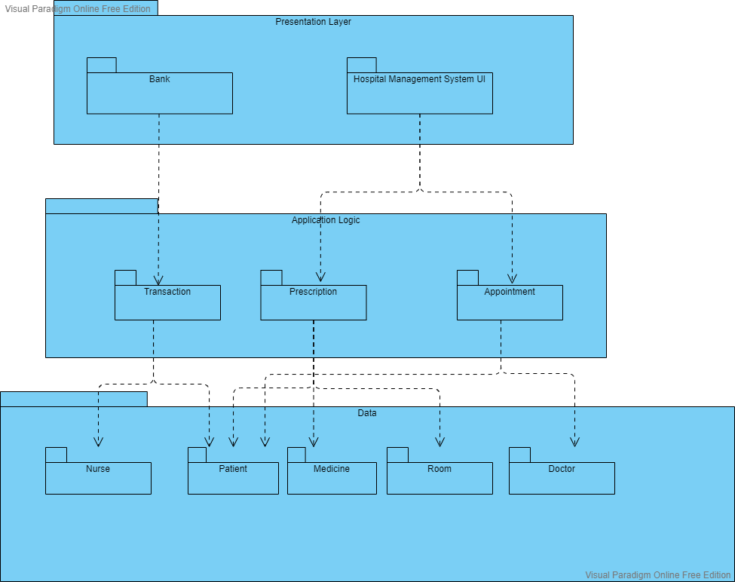

Component Diagram

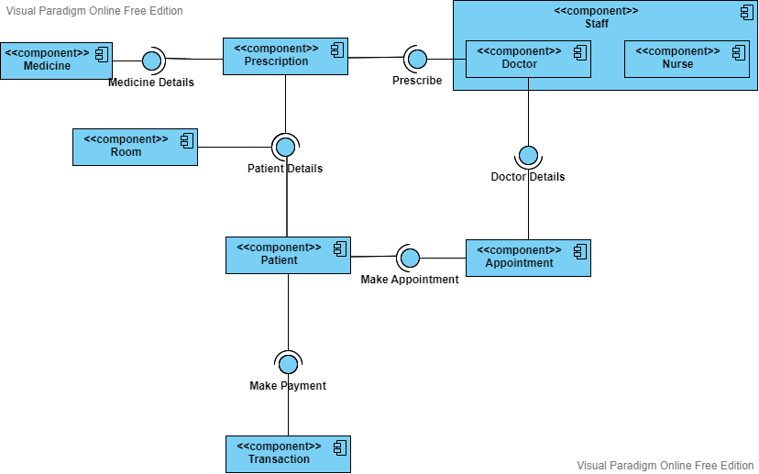

Deployment Diagram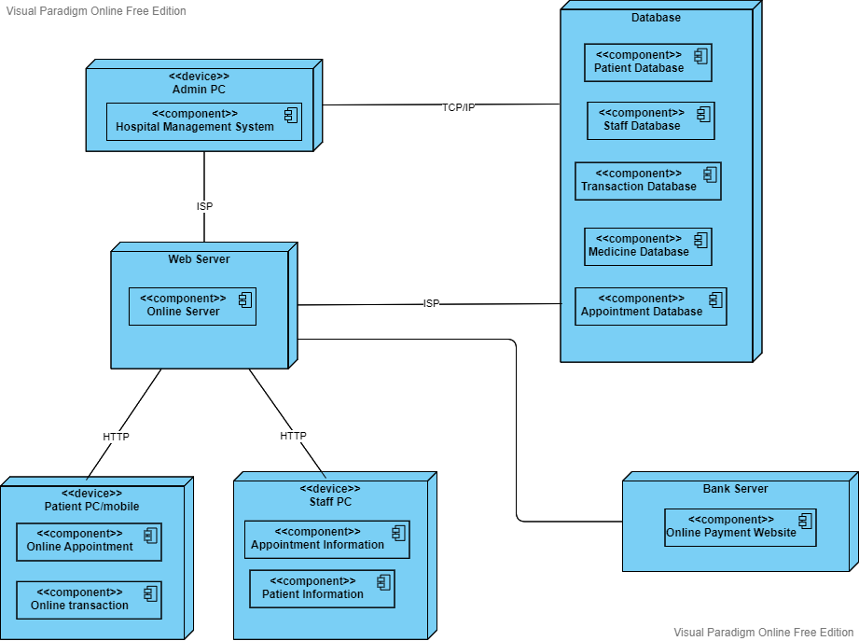

Clarification:

Based on the package diagram and deployment diagram, the hospital management system is using 3-tier architecture style which consists of Data layer), Presentation layer and Application Logic layer. Client tier will never communicate directly with the data tier and all communication among the tiers must pass through the middle tier. This can maintain the data integrity in database. Better and finer security control to whole system can be achieved by enforcing security differently based on the requirements to each tier. For example, the business layer and data layer which require higher level of security protection can be put behinds firewall for protection. Besides, it is scalable and easy for maintenance because the changes on one tier will not affect the other tiers. Due to the logical grouped components and the decoupling brought by 3-tier architecture, any new features can be added easily without affecting too much on other components and this components can be reused.